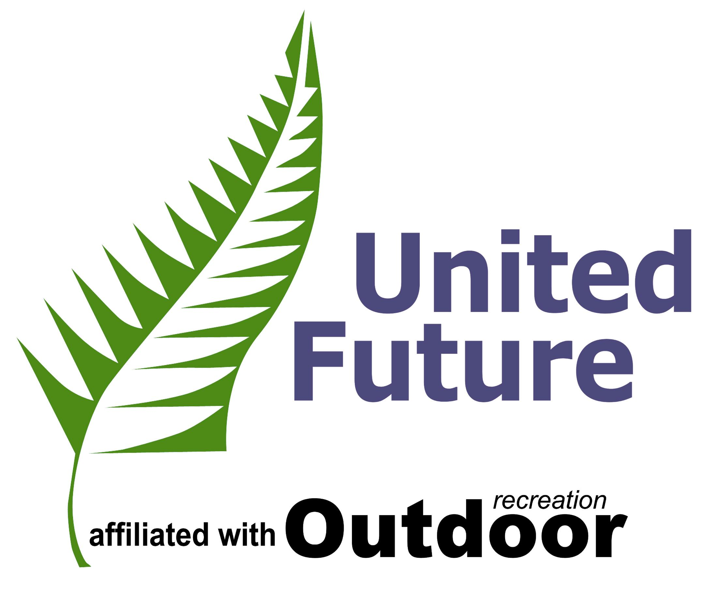

Media notice

United Future leader, Hon Peter Dunne, will host a breakfast meeting on Wednesday, November 24, 2004, from 7.30am to 8.45am at the West Plaza Hotel, Dorset Suite, Wakefield St, Wellington.

Business and community leaders have been invited to hear addresses on accelerating the region’s roading infrastructure improvements and the consequent effect on business.

Speakers: Hon Peter Dunne, Ohariu-Belmont MP and Jayne Gale of the New Zealand Automobile Association.

All media welcome.

For further details: 0800 836 947
ufnzhq@xtra.co.nz

